Visual network descriptor for Mininet

User's Guide

Introduction

This manual will allow you to understand how it works and learn to use all the functionalities of the visual network descriptor for Mininet.

If you want more information and learn quickly and easily, you can watch this [video](https://youtu.be/d2gNxIE7T6U), it contains a detailed explanation of each of the functionalities of the Visual Descriptor.

](https://youtu.be/d2gNxIE7T6U)

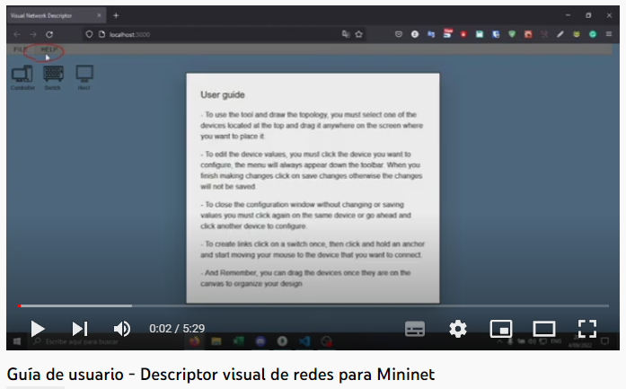

Contents

**1.** **Help option** 4

**2.** **Topology creation** 5

**3.** **Device connection** 6

**4.** **Device configuration** 8

- **Driver Settings:**controller settings allow to change the name. 8

- **Switch configuration:**switch configuration only allows changing the name and MAC address. 9

- **Host configuration:**the host allows you to change the name, IP address, Mac address and subnet mask. 11

- **Link configuration:**To configure a link you must click on the link of your interest, in this way the configuration panel will be displayed where you can edit the delay (ms), the loss (%) and the bandwidth (Mbit/s). 12

**5.** **remove devices** 14

**6.** **Export topology** 15

**7.** **Mininet execution** 18

**8.** **Create new topology** 19

**9.** **load topology** 20

**Warning!**

**Avoid using the browser's reload page option to avoid state problems in the visual descriptor. If you happen to use this option, please enter the FILE menu of the descriptor and select the New option to remove all data in the cache and start a new project.**

Help option

Clicking on the Help option displays a summarized help on each of the functionalities of the visual descriptor.

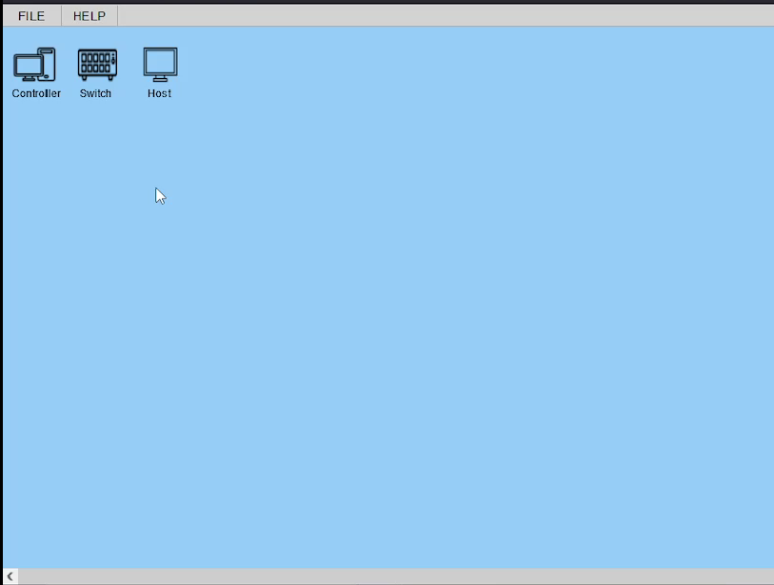

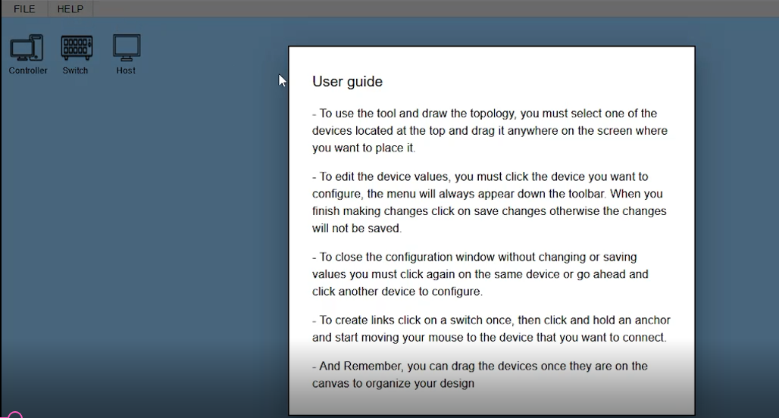

1. **Topology creation**

To create the topology, you must select the device you are going to use and drag it onto the canva.

1. **Device connection**

To connect the devices, you can add a link by clicking on the switch, when selecting the switch four circles will appear around the device, click on any of these and drag to the device you want to connect to, as shown in the following image:

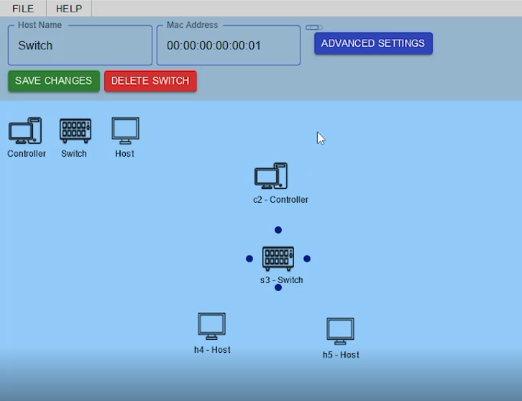

As you can see below, when a device is connected, the link changes color, showing that the connection was successful.

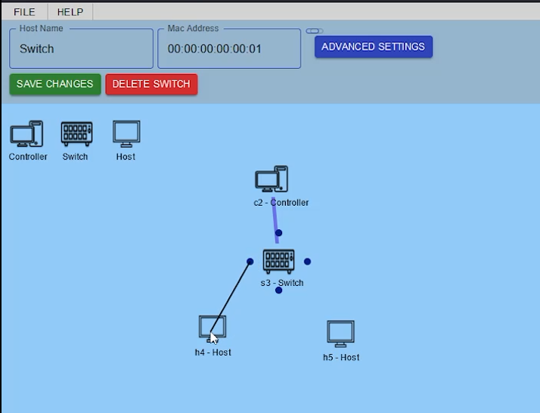

**Note:** Switches are the only devices enabled to make connections, because it can be connected to the controller and host, the other devices, when selected, will not display the circles, since they do not handle the same functionality as the switch, this is because the devices host and controller have many connection restrictions.

1. **Device configuration**

For the configuration of the devices, you must select it, then the configuration panel appears at the top of the canvas.

* + **Driver Settings:** controller settings allow to change the name.

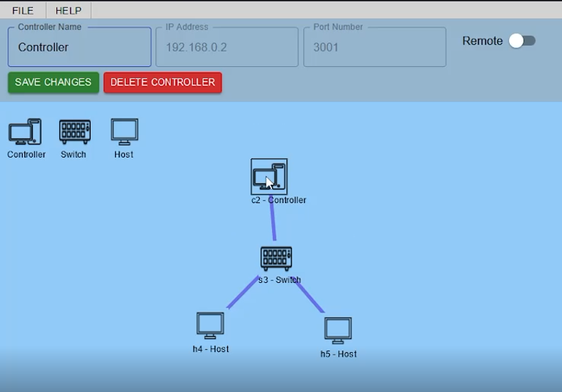

**Note:** when the remote option is not activated the IP address and the port do not exist, for this reason they cannot be configured.

By activating the remote option, you can edit the IP address and port.

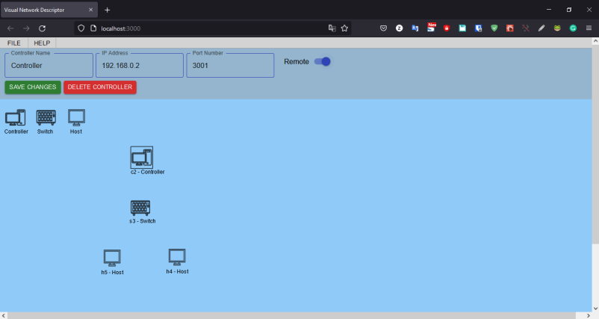

To save the changes, you must click on the green button “SAVE CHANGES”

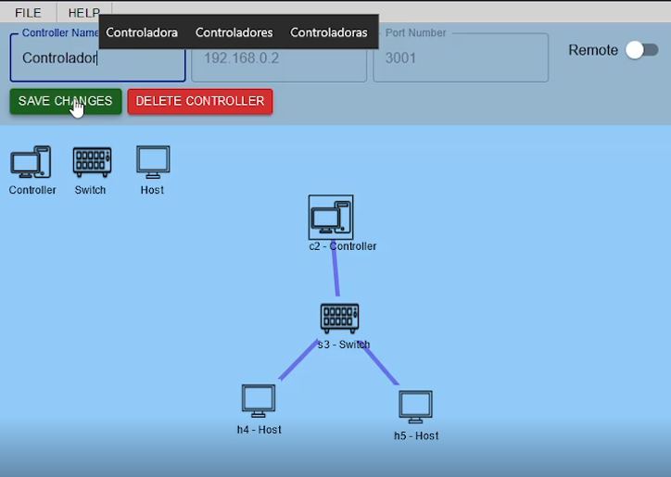

* + **Switch configuration:** switch configuration only allows changing the name and MAC address.

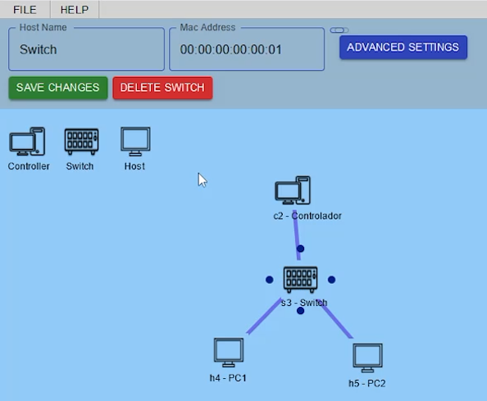

On the other hand, there is the advanced configuration option, when clicking on the blue button “ADVANCED SETTINGS” a warning notice is displayed, since in this option you can edit the port parameter.

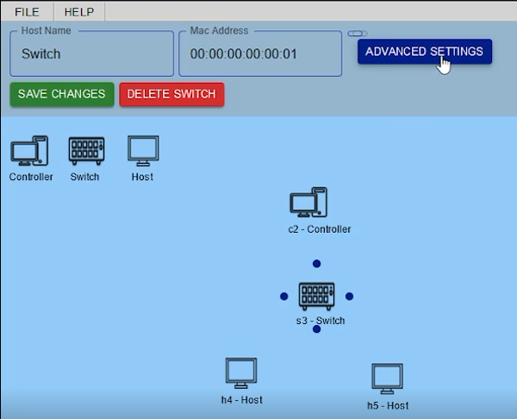  
The OVS protocol is assigned by default, to close the advanced configuration option you must click on the same blue button “ADVANCED SETTINGS”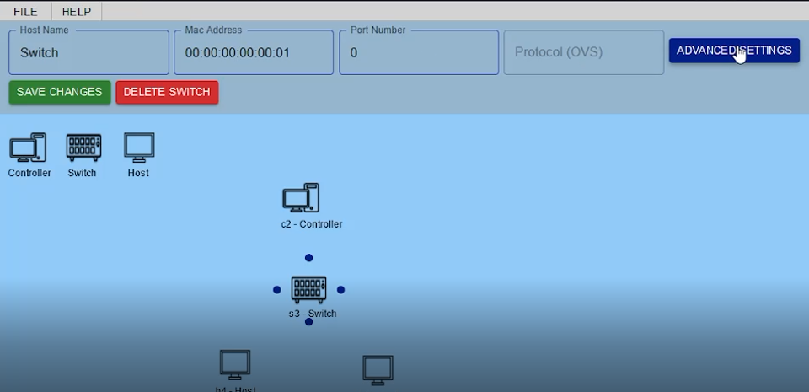

* + **Host configuration:** the host allows you to change the name, IP address, Mac address and subnet mask.

If you want to change the IP address, you cannot use the same address of another device, when doing so the system will show a warning and you will not be able to save the changes, for example, in this case the IP address is changed to 192.168.0.2, this address is assigned to another device.

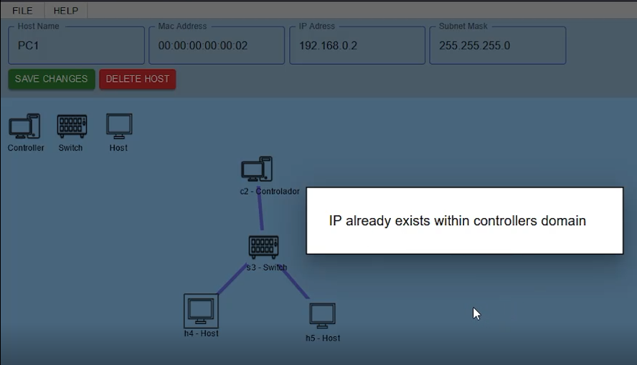

The same goes for the MAC address.

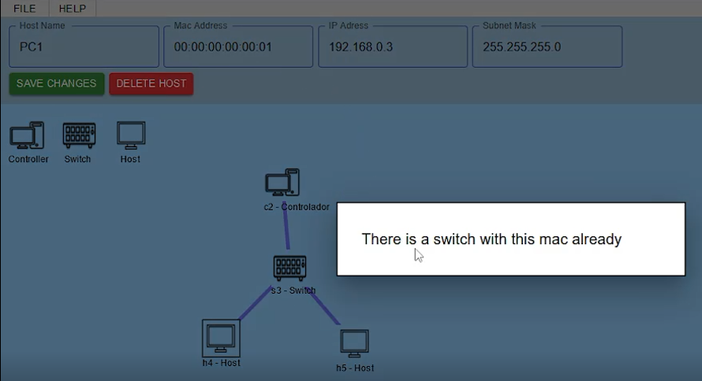

* + **Link configuration:** To configure a link you must click on the link of your interest, in this way the configuration panel will be displayed where you can edit the delay (ms), the loss (%) and the bandwidth (Mbit/s).

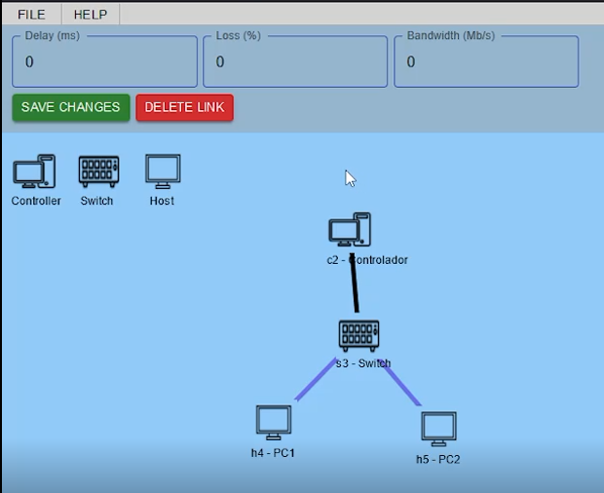

Remember that you cannot use non-matching characters in the link settings

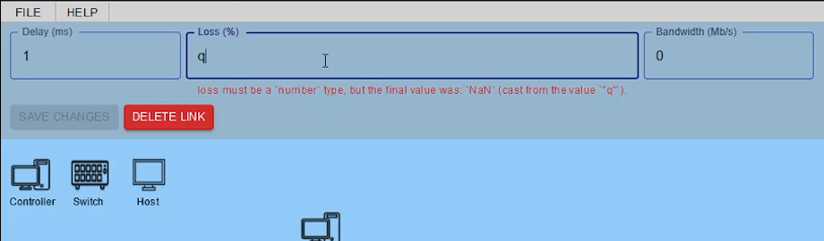

**Note:** You cannot leave empty fields and you cannot leave incomplete IP or MAC addresses, otherwise the system does not allow you to save the settings made and an error appears as shown below.

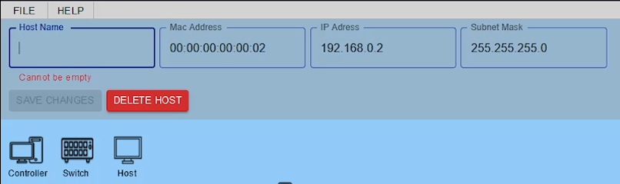

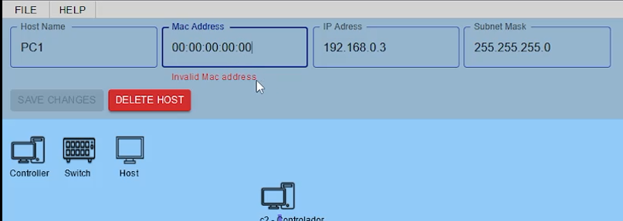

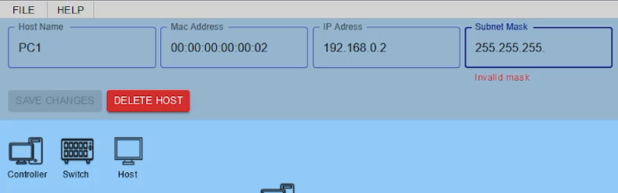

* + **Remove devices**

To delete you must click on the device of your interest, in this way the configuration panel will be displayed, next to the save button there is a red button with the name "delete" click on it to delete the device.  
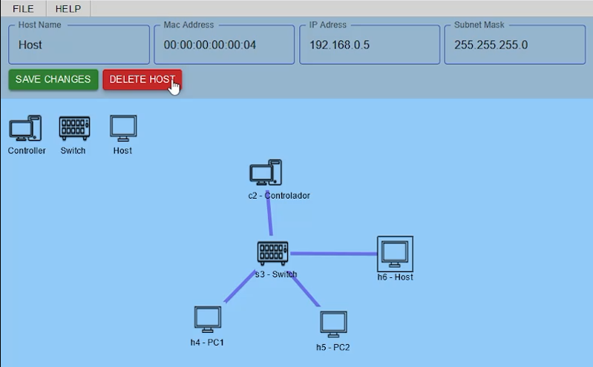

**Note**- If the device has connections, these links are also removed along with the team and the configuration panel is removed.

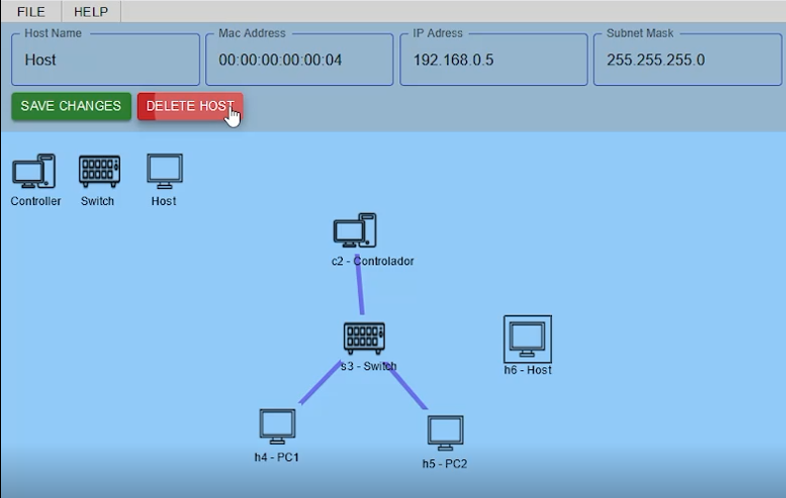  
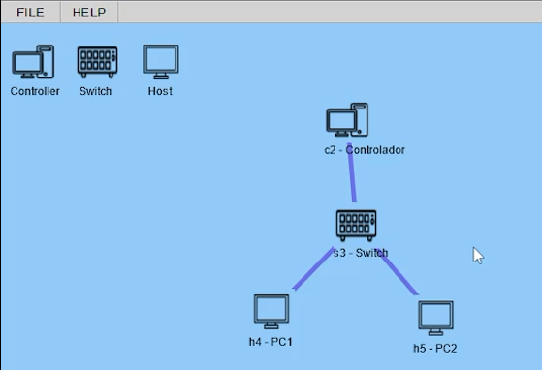

1. **Save topology**

To save the topology made, you must enter the FILE menu located in the left corner of the application, there you can find the save option.

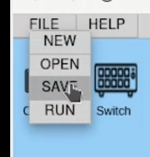

Clicking on save will open an ad that will allow you to assign a name to your topology, once you type a name you must click on the blue “DONE” button

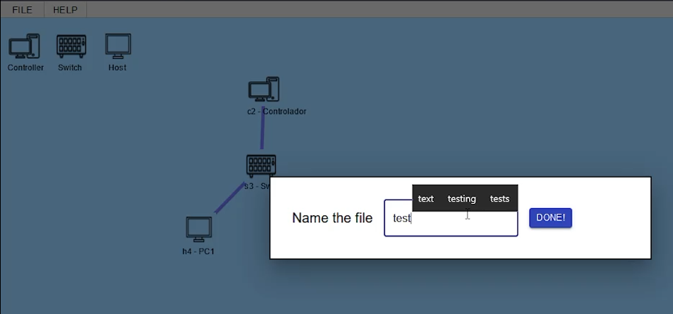

When clicking, the .json and .py files of the topology are downloaded in the path Documents/VND/

You can check the folder to verify that the files have been saved correctly with the corresponding data.

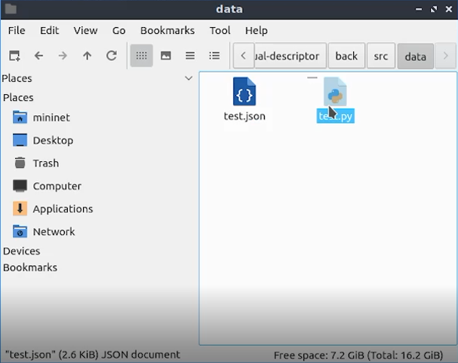

**.json file**, contains the topology of the network with the corresponding vectors to be loaded again in the visual network descriptor.

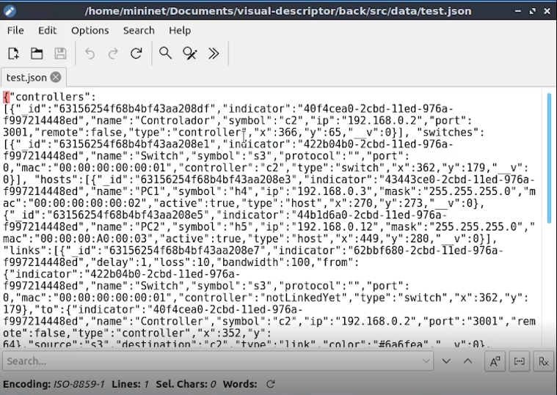

**.py file**, contains the configuration of the devices and links to be executed in Mininet.

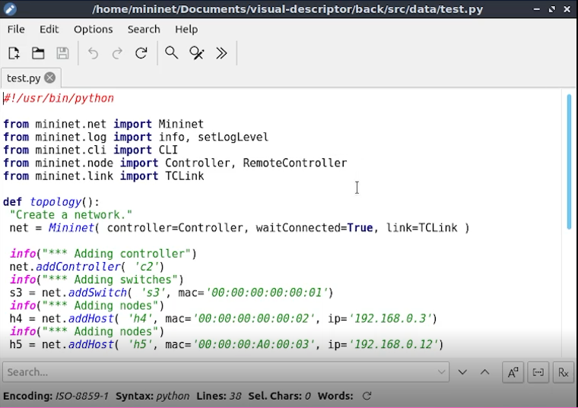

1. **Mininet execution**

When you save the topology and click on the RUN button, Mininet is executed with the topology made.

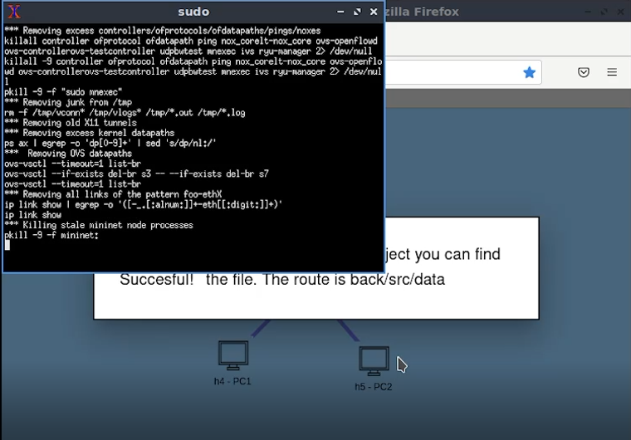

You can run the dump and pingall commands to check that the topology and connections have been configured correctly.

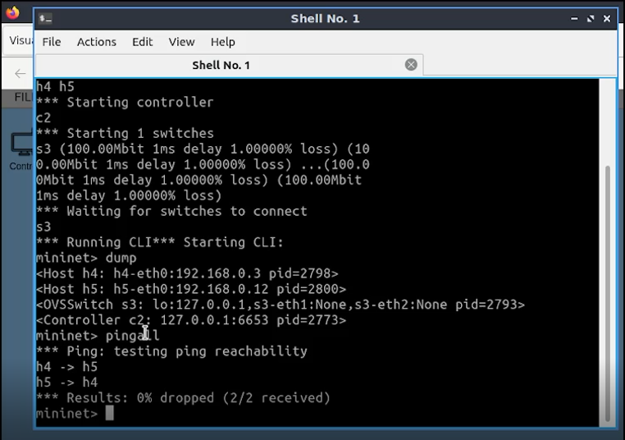

1. **Create new topology**

To create a new topology, you must enter the FILE menu and select the New option.

When clicking on New, a warning will appear that all the devices made will be deleted.

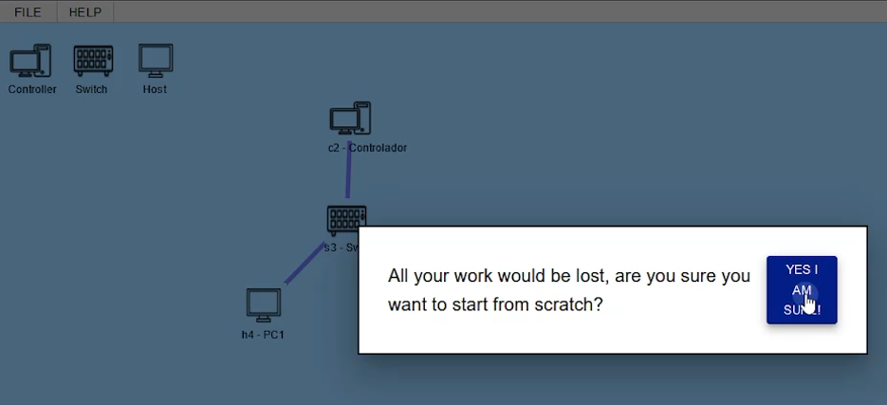

1. **load topology**

To load a topology made, you must enter the FILE menu and select the Open option, a window will open that allows you to search for the .json file and load it.

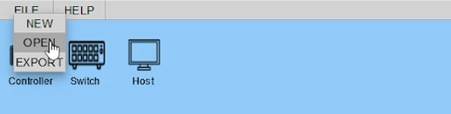

Select the browser option, look for the .json file, which is in the path documents/VND.

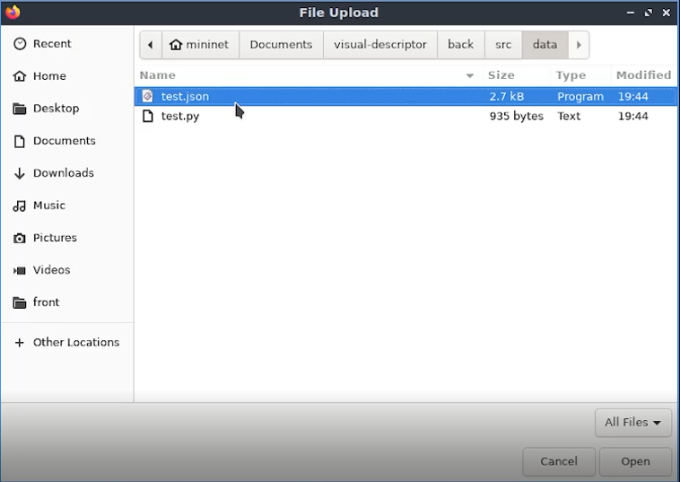

Then click on the Upload button.

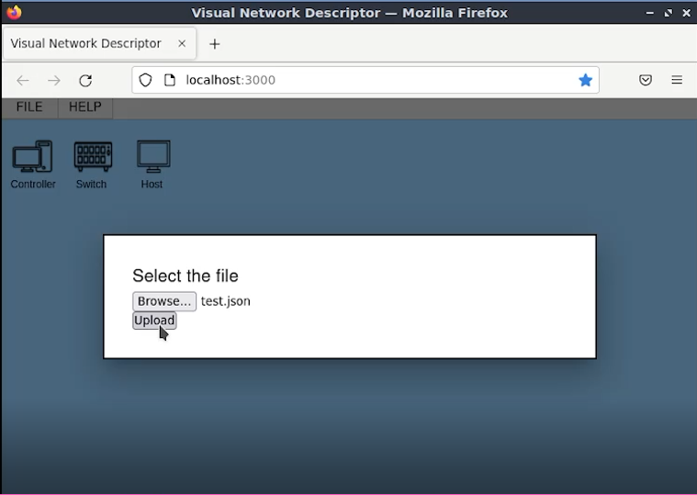

In this way the entire topology will be loaded, and you can edit it again, check that the connections and configurations are correct.

